Documentation for Simplex Codes

By: Immanuel Manohar
(idmanohar@crimson.ua.edu)

For: MA520 – Linear Optimization Final Project

Implemented Algorithms:
- Two Phase Simplex
- Revised Simplex
- Dual Simplex
- Transportation Problem
- Unbalanced Transportation Problem
The codes are commented when necessary and displays all the steps in the iteration procedure.

General Information:
The following functions are created to address all the problems:
Function Name | Role
Simplex | Primary function that helps obtain and store variables as .mat files to be used later. This accepts either standard simplex, transportation or transshipment problems. (This is the starting function to run) Eg: simplex(1) to solve a standard simplex., simplex(a,’fname.mat’) to use stored values in fname.mat to run simplex.
Simplex1 | Function used to separate uses of Two Phase / Dual / Revised / Primal Dual Simplex algorithms
Two_phase_simplex | Function that solves two phase simplex, returns optimal primal variables X and cost Z.
Simplex_iteration | Function block that helps perform the iterations in two phase simplex.
Revised_simplex | Function that solves revised simplex, returns optimal primal variables X and cost Z.
Revised_simplex_iteration | Function block that helps perform the iterations in two revised simplex.
Dual_simplex | Function that helps solve Dual simplex problems.
Simplex_transportation | Function block that helps solve both balanced and Unbalanced transportation problems.
Simplex_balancedtransportation | Function that helps solve balanced transportation problems (called from simplex_transportation)
Cycle | A function block that assists in finding the next basic feasible solution with the new variable added. In solving balanced or unbalanced transportation problem.
Example_1.mat, Example_2.mat, Example_3.mat, Example_4.mat, Example_5.mat | .mat files with preentered values for illustrating the various simplex algorithms. The examples are detailed further in this report. The examples are based off the book Linear and Non-linear programming by Luenberger.

Examples Used:

Example 1: (Taken from example 2 pg 51 of Linear and non-linear programming by Luenberger) Used to illustrate both Two phase and Revised Simplex.

$$\min{4x_{1}+x_{2}+x_{3}} \\ st, 2x_{1}+x_{2}+2x_{3}=4 \\ 3x_{1}+3x_{2}+x_{3}=3 \\ x_{1},x_{2},x_{3}≥0$$
Implement by calling : simplex(1) (or) simplex(1,Example_1.mat) in MATLAB
The same is used as example 2 for revised simplex.
Implement by calling : simplex(1) (or) simplex(1,Example_2.mat) in MATLAB

Example 3: Dual simplex illutstration: (Taken from Pg 101 of Book)
$$\min{3x_{1}+4x_{2}+5x_{3}} \\ ST:x_{1}+2x_{2}+3x_{3}≥5 \\ 2x_{1}+2x_{2}+x_{3}≥6 \\ x_{1},x_{2},x_{3}≥0$$
Implement by calling : simplex(1) (or) simplex(1,Example_3.mat) in MATLAB

Example 4: Balanced Transportation Problem ( Book: Pg 57)
$$a=\left[30, 80, 10, 60\right] \\ b=\left[10, 50, 20, 80, 20\right] \\ C=\left[\begin{aligned}\begin{matrix}3 & 4\end{matrix} \begin{matrix}6 & 8 & 9\end{matrix} \\ \begin{matrix}2 & 2\end{matrix} \begin{matrix}4 & 5 & 5\end{matrix} \\ \begin{matrix}2 & 2\end{matrix} \begin{matrix}2 & 3 & 2\end{matrix} \\ \begin{matrix}3 & 3\end{matrix} \begin{matrix}2 & 4 & 2\end{matrix}\end{aligned}\right]$$
Implement by calling : simplex(2) (or) simplex(1,Example_4.mat) in MATLAB

Example 5: UnBalanced Transportation Problem
$$a=\left[30, 80, 10, 60\right] \\ b=\left[10, 50, 20, 80\right] \\ C=\left[\begin{aligned}\begin{matrix} & 4\end{matrix} \begin{matrix}6 & 8 & 9\end{matrix} \\ \begin{matrix} & 2\end{matrix} \begin{matrix}4 & 5 & 5\end{matrix} \\ \begin{matrix} & 2\end{matrix} \begin{matrix}2 & 3 & 2\end{matrix} \\ \begin{matrix} & 3\end{matrix} \begin{matrix}2 & 4 & 2\end{matrix}\end{aligned}\right]$$
Implement by calling : simplex(2) (or) simplex(1,Example_5.mat) in MATLAB

The MATLAB Codes:
The functions are organized as below:

Simplex

Type-III (Not implementd)

Type-II
Type - I

Transhipment
Balanced Transportation
Two Phase Simplex
Revised Simplex

Primal Dual Simplex
(Not Implemented)
Dual Simplex
UnBalanced Transportation

The following function is used to start solving any simplex problem belonging to the 5 examples illustrated above:

Universal Functions:
%********************************************************************************
%Function coded by Immanuel Manohar (idmanohar@crimson.ua.edu)
%*********************************************************************************
%function designed for solving standard linear programming problems:
%solves the three types of problems (1. Standard Linear programming,
%2. Transportaion and 3. Transshipment) using 7 differnt algorithms. Details are given below:
%
%The funciton could be called simply as:
%simplex(Type) where Type is 1 / 2 / 3 based on above.
%
%or if you want to use a .mat file with preentered values,
%
%simplex(Type,'file_name') In this the Type does not matter and will be
%overwritten from the file if present.
%
% This function returns a saved matfile with the olutions.
% The solutions are in variables X -> The optimal solution if
% exists, else returns all possible Basic feasible solutions or returns NA
% if infeasible.
% Z -> the optimal cost if exists or gives NA.
%
%
%Type 1:
%standard linear program:
%min c'x
%st Ax = b
% x >=0.
%
%solvers:
% 'TPS' : two phase simplex
% 'Revised' : Revised simplex
% 'DS': Dual simplex algorithm
% 'PD': Primal Dual Algorithm
%
%Type 2:
%network flow problem using graphs.
% C = cost of flow between nodes.
% bi = outflow - inflow at each node i.
% bi >0 for source node,
% bi < 0 for sink and
% bi = 0 for relay nodes.
%
%Type 3:
% Transportation problem
% C = cost of flow between nodes.
% a: quantity at source
% b: demand
% S: storage costs if any.

function simplex(Type,varargin)
clc;
if isempty(varargin)== 1
switch Type
case 1
reenter =1;
while reenter == 1
disp('You are trying to solve a standard Linear Program')
disp('Enter the input parametrs')
disp('-------------------------')
c = input('Enter the cost values,c: ');
c = c(:)';
A = input('Enter the constraint matrix A: ');
b = input('Enter the right side of the constraint equation, b: ');
b= b(:);
solver = input('Enter solver to be used:\\n (TP- Two phase simplex), (Revised - Revised Simplex), (DS - Dual Simplex),\\n (PD - Primal Dual Algorithm), Your Choice: ','s');
disp('Input parameters are entered')
disp('----------------------------')
disp(sprintf('solution to be found using %s:',solver));
disp('The cost c is given by: ');
c
disp('The constraint matrix A:');
A
disp('The right side of the constraint equation: b');
b
store = input('confirm above and store values? (1 = yes, 0 = no)');
if store ==1
name1 = input('enter file name to store as:' ,'s');
name = sprintf('%s.mat',name1);
save(name,'c','A','b','Type','solver','name');
reenter = 0;
[X,Z,D] = simplex1(name);
disp('-------------------------')
disp ('The optimal basic feasible solution(s) is: ')
X
disp('-------------------------')
disp (sprintf('The optimal cost is Z : %d',Z));
Z
disp('The dual is: ')
D
fprintf('---------(Results are also stored in the file name: %s)----------------',name)
save(name,'c','A','b','Type','solver','X','Z','name');
else
reenter =1;
end
end
case 2
reenter = 1;
while reenter == 1
disp('You are trying to solve a transportation problem')
disp('Enter the input parametrs')
disp('-------------------------')
C = input('Enter the cost matrix,c: ');
a = input('Enter the source quantities: ');
b = input('Enter the destination quantities: ');
S = input('Enter the storage cost (if any): ');

disp('Input parameters are entered')
disp('----------------------------')
disp('solution to be found using Array format of simplex based on northwest corner rule');
disp('The cost c is given by: ');
C
disp('The source quantities is given by:');
a
disp('The Destination quantities is given by:');
b
disp('The Storage cost is given by:')
S
store = input('confirm above and store values? (1 = yes, 0 = no)');
if store ==1
name1 = input('enter file name to store as:','s');
name = sprintf('%s.mat',name1);
save(name,'C','a','b','S','Type','name');
reenter = 0;
[X,Z] = simplex_transportaion(name);
disp('-------------------------')
disp ('The optimal basic feasible solution(s) is: ')
X
disp('-------------------------')
disp (sprintf('The optimal cost is Z : %d',Z));
Z
fprintf('---------(Results are also stored in the file name: %s)----------------',name)
save(name,'C','a','b','S','Type','X','Z','name');
else
reenter = 1;
end
end
case 3
reenter = 1;
while reenter == 1
disp('You are trying to solve a network flow problem')
disp('Enter the input parametrs')
disp('-------------------------')
C = input('Enter the cost matrix,c: ');
b = input('Enter b, the node demand: ');

disp('Input parameters are entered')
disp('----------------------------')
disp('solution to be found using Network format for Simplex');
disp('The cost c is given by:');
C
disp('Demands of each node is given by:');
b

store = input('confirm above and store values?');
if store ==1
name1 = input('enter file name to store as:','s');
name = sprintf('%s.mat',name1);
save(name,'C','b','Type','name');
reenter = 0;
[X,Z] = simplex_network(name);
disp('-------------------------')
disp ('The optimal basic feasible solution(s) is: ')
X
disp('-------------------------')
disp (sprintf('The optimal cost is Z : %d',Z));
Z
fprintf('---------(Results are also stored in the file name: %s)----------------',name)
save(name,'C','b','Type','X','Z','name');
end
end
otherwise
error('Enter a valid Type (1/2/3)')

end

else
fname = varargin{1}
load(fname);

switch Type
case 1
[X,Z,D] = simplex1(name);
disp('-------------------------')
disp ('The optimal basic feasible solution(s) is: ')
X
disp('-------------------------')
disp (sprintf('The optimal cost is Z : %d',Z));
Z
disp('The dual is: ')
D
fprintf('---------(Results are also stored in the file name: %s)----------------',name)
save(name,'c','A','b','Type','solver','X','Z','name');
case 2
[X,Z] = simplex_transportaion(name);
disp('-------------------------')
disp ('The optimal basic feasible solution(s) is: ')
X
disp('-------------------------')
disp (sprintf('The optimal cost is Z : %d',Z));
Z
fprintf('---------(Results are also stored in the file name: %s)----------------',name)
save(name,'C','a','b','Type','X','Z','name');
case 3
[X,Z] = simplex_network(name);
disp('-------------------------')
disp ('The optimal basic feasible solution(s) is: ')
X
disp('-------------------------')
disp (sprintf('The optimal cost is Z : %d',Z));
Z
fprintf('---------(Results are also stored in the file name: %s)----------------',name)
save(name,'c','b','Type','X','Z','name');
otherwise
error('The type in file does not exist');
end

end

The function simplex1 is used to select which simplex algorithm to use to solve the standard simplex model.:
%Code by Immanuel Manohar (idmanohar@crimson.ua.edu)
%selects the algorithm to solve the Stabndard Linear Programming
function [X,Z,D] = simplex1(fname)

load(fname)

switch solver
case 'TP'
[X,Z] = Two_phase_simplex(fname);
D = 'NA';

case 'Revised'
[X,Z,D] = Revised_simplex(fname);

case 'DS'
% error('Will be implemented later');
[X,Z] = Dual_simplex(fname);
D = 'NA';
case 'PD'
error('Will be implemented later');
%[X,Z,D] = Primal_Dual(fname);
end

Two Phase simplex:
The two phase simplex algorithm has two function blocks.
Part – 1
This following function block determines the parameters for phase I and phase II and calls the simplex_iterations.m function to solve the LP in both Phase I and Phase =II.
function [X,Z] = Two_phase_simplex(fname)

load(fname)

n = size(A,2);
fprintf('Number of optimization variables: %d \n', n )
m = size(A,1);
fprintf('Number of basic variables: %d \n', m )

%% Phase - I finding the initial basic feasible solution

% creating new A with dummy variables
b= b(:);
c = c(:)';
A_new = [A eye(size(A,1))];

c_new = [zeros(1,size(A,2)) ones(1,size(A,1))];

% b remains unaltered.

% simplex_iteration with new A and cost to obtain initial BFS.
basic_variables = zeros(1,size(A_new,2));
basic_variables(size(A,2)+1:end)= ones(1,size(A,1)); %the dummy variables form the initial basic feasible solution in Phase I.
disp('Phase I to determine initial basic feasible solution ')
[A_return, b_return,basic_variables,~,~,flag] = simplex_iteration(A_new,b,c_new,basic_variables);
if flag == 0
X = 'NA';
Z = 'NA';
else
disp('Phase II to determine optimal basic feasible solution ')
A_refined = A_return(1:size(A,1), 1: size(A,2));
b_refined = b_return;
c_refined = c;
[A, b,basic_variables,Z,~,flag] = simplex_iteration(A_refined,b_refined,c_refined,basic_variables);
if flag == 0
X = 'NA';
Z = 'NA';

else
% Find columns of A that are basic.
X = zeros(1,size(A,2));
for i = 1 : size(A,2)
if basic_variables(i) == 1
X(i) = b(A(:,i) == 1);
end
end
disp('****************************************************** ')
display(sprintf(' The optimal solution is given by: X : %s \n',num2str(X)))
display(sprintf(' The optimal objective value is given by: Z : %d \n',Z))
disp('******************************************************')

end
end

Part – 2

The simplex iterations are solved using the function below:
%Code by Immanuel Manohar (idmanohar@crimson.ua.edu)

function [A_return, b_return, basic_variables, z, r, flag] = simplex_iteration(A,b,c,basic_variables)
flag = 1;
z = 0;
r = c;
%forming initial tableau:

Tableau = [A b;r 0];

disp('The initial simplex tableau is given by: ')
Tableau

%Find the columns corresponding to the initial basic feasible solution and
%setting the corresponding cost to zero.
bs_no = 0;
for i = 1: size(A,2)
if (norm(A(:,i),1) == norm(A(:,i),Inf)) && (norm(A(:,i),1) == 1)
%i is a column corresponding to basic feasible solution.
bs_no = bs_no+1;
pivot_column = i;
pivot_row = A(:,i)== 1;

if r(i) ~= 0
Tableau(end,:) = Tableau(end,:)-Tableau(pivot_row,:).*r(i);
end
end
end

if bs_no ~= size(A,1)
error('Need initial basic feasible solution to start simplex iteration ');
end

disp(sprintf('The 1st tableau after transforming the last row is: '))
Tableau

Iteration = 1;
while (Iteration < 20)
r = Tableau(end,1:end-1);
A = Tableau(1:end-1,1:end-1);
b = Tableau(1:end-1,end);
z = -Tableau(end,end);
if sum(r < 0) == 0
display('All relative cost coeffitients > 0, optimal solution reached')
A_return = A;
b_return = b;
return
else
Iteration = Iteration +1;
[~,Id] = min(r);
pivot_column = Id(1); %incase there are multiple r(i) with same minimum value.
basic_variables(pivot_column) = 1;
ratio = b./A(:,pivot_column);
if sum((ratio >= 0)) ==0
display('The problem is unbounded')
A_return = A;
b_return = b;
flag = 0;
return
end

[~,Id] = min((ratio > 0).*ratio + (ratio <= 0).*Inf);
pivot_row = Id(1); %incase there are multiple ratios with the same minimum value >0;
basic_variables(A(pivot_row,:)== 1) = 0;
fprintf('Pivot Row: %d; Pivot Column: %d \n',pivot_row,pivot_column)
%pivoting with the found pivot element:
Tableau(pivot_row,:) = Tableau(pivot_row,:)./Tableau(pivot_row,pivot_column);
temp = Tableau(pivot_row,:);
Tableau = Tableau - diag(Tableau(:,pivot_column))*ones(size(Tableau))*diag(temp);
Tableau(pivot_row,:) = temp;
disp(sprintf('The %d tableau is: \n', Iteration))
Tableau
end
end

Revised Simplex:
This also has two functions similar to the previous one. The first block below initiates the different Phases, the Second block solves the simplex algorithm.
Part –1

%Code by Immanuel Manohar (idmanohar@crimson.ua.edu)

function [X,Z,D] = Revised_simplex(fname)
load(fname)

n = size(A,2);
fprintf('Number of optimization variables: %d \n', n )
m = size(A,1);
fprintf('Number of basic variables: %d \n', m )

%% Phase - I finding the initial basic feasible solution

% creating new A with dummy variables
b= b(:);
c = c(:)';
A_new = [A eye(size(A,1))];

c_new = [zeros(1,size(A,2)) ones(1,size(A,1))];

% b remains unaltered.
% simplex_iteration with new A and cost to obtain initial BFS.
basic_variables = zeros(1,size(A_new,2));
basic_variables(size(A,2)+1:end)= ones(1,size(A,1)); %the dummy variables form the initial basic feasible solution in Phase I.
disp('Phase I to determine initial basic feasible solution ')
[A_return, b_return,basic_variables,~,flag_new] = revised_simplex_iteration(A_new,b,c_new,basic_variables);
if flag_new == 0
X = 'NA';
Z = 'NA';
else
disp('Phase II to determine optimal basic feasible solution ')
A_refined = (A_return(1:size(A,1), 1: size(A,2)));
b_refined = b_return;
c_refined = c;
basic_variables = basic_variables(1:size(A,2));
[A, b,basic_variables,D,flag_new] = revised_simplex_iteration(A_refined,b_refined,c_refined,basic_variables);
if flag_new == 0
X = 'NA';
Z = 'NA';

else
% Find columns of A that are basic.
X = zeros(1,size(A,2));
for i = 1 : size(A,2)
if basic_variables(i) == 1
X(i) = b(A(:,i) == 1);
end
end
Z = c_refined*X(:);
disp('****************************************************** ')
display(sprintf(' The optimal solution is given by: X : %s \n',num2str(X)))
display(sprintf(' The optimal objective value is given by: Z : %d \n',Z))
disp('******************************************************')

end
end

Part – 2
%Function coded by Immanuel Manohar (idmanohar@crimnson.ua.edu)

%Performs Revised simplex iterations
function [A_return, b_return, basic_variables,y, flag] = ...
revised_simplex_iteration(A,b,c,basic_variables)
flag = 1;
b = b(:);
c= c(:)';
basic_variables = basic_variables(:)';
D = (basic_variables == 0);
CD = c(D==1);
CB = c(basic_variables==1);
B = A(:,basic_variables==1);
AD = A(:,D);
y = CB*(B^-1);
RD = CD - y*AD;
a0_bar = B^-1*b;
Iteration = 1;

basic_row = round(zeros(size(basic_variables)));
basic_row(basic_variables ==1) = round(sum(diag(1 : size(B,2))*B)); %stores which row has the non-zero component in the basis matrix B.

display('Initial Tableau:')
basics = find(basic_variables==1);
non_basics = find(D==1);
Tableau = [basics(:) B^-1 a0_bar(:)]

while (Iteration < 20)

if sum(RD<0) == 0
display('All relative cost coeffitients > 0, optimal solution reached')
A_return = (B^-1)*A;
b_return = a0_bar;

return
else
[~,ID] = min(RD);
pivot_column = non_basics(ID(1));
% AD = A(:,D);

aq = A(:,pivot_column);
aq_bar = (B^-1)*aq; %aq interms of current basis

if sum(aq_bar > 0) == 0
display('The problem is unbounded')
A_return = A;
b_return = b;
flag = 0;
return
else
ratio = a0_bar./aq_bar;
[~,Id] = min((ratio > 0).*ratio + (ratio <= 0).*Inf);
pivot_row = Id(1);
fprintf('Pivot Row: %d; Pivot Column: %d \n',pivot_row,pivot_column)

column_replace = find(basic_row == pivot_row);

basic_variables(column_replace) = 0;
basic_variables(pivot_column) = 1;
basic_row(column_replace) = 0;
basic_row(pivot_column) = pivot_row;

B = A(:,basic_variables==1);

D = (basic_variables == 0);
fprintf('%d Tableau:', Iteration)
AD = A(:,D);
basics = find(basic_variables==1);
non_basics = find(D==1);

a0_bar = B^-1*b;
Tableau = [basics(:) B^-1 a0_bar(:)]
Iteration = Iteration +1;
CD = c(D==1);
CB = c(basic_variables==1);
y = CB*(B^-1);
RD = CD - y*AD;
end
end
end

The Dual Simplex:
The following function implements the dual simplex method:
%function coded by Immanuel Manohar (idmanohar@crimson.ua.edu)
%inspired by codes by Kaushik (A friendly collegue)
%Dual simplex helps avoid phase I of finding an Initial B.F.S.
%solves
%min c'*x
%st
%Ax <= b;
% x>=0;
function [X,Z,flag] = Dual_simplex(fname)
flag = 1;
load(fname)

b = b(:); % converting the b into column matrix b=transpose(b)
[m, n] = size(A); % n -> Number of Primal variables, m -> Number of Dual Variables

eq = 0;
if length(c) < n % length c less than numver of primal variables.
c = [c zeros(1,n-length(c))]; % Assign zeros to cost of extra primal variables for which cost was not specified
end

A=[A eye(m)]; % adding the identity matrix for whole A
ncol = size(A,2); % length of Matrix A
c = [c zeros(1,ncol-length(c))]; % make the length of c equal to ncol of A
Tableau = [A b; c 0];
subs = ncol+1:ncol+m; % this indicates column number which has identity matrix possess as basic variables

disp(sprintf('\n\n Initial tableau'))
Tableau
A = Tableau;
[bmin, row] = min(b); % to find the min b of RHS in Ax>=b
tbn = 0; % initialize the number of tableau
%Dual-simplex operation% Pivot operation
while ~isempty(bmin) && bmin < 0 && abs(bmin) > eps
if A(row,1:m+eq+n) >= 0 % checking whether the row particular to negative b is not positive
disp(sprintf('\n Empty feasible region \n'))
% varargout(1)={subs(:)}; % if the row is positive , position of the basic variables
% varargout(2)={A}; % final A value
% varargout(3) = {zeros(n,1)}; % flush all the basic variables to zeros
% varargout(4) = {0}; % final cost value set as zero
X = 'NA'
Z = 'NA'
flag = 0;

return
end
aa = A(m+1,1:m+n);
bb = A(row,1:m+n);
bb1 = bb + (bb == 0).*1;
[~,col] = max(((aa./bb1).*(bb<0))+(bb>=0).*-10000); %to find the pivot element
disp(sprintf(' pivot row-> %g pivot column-> %g',row,col))
subs(row) = col; % the pivot element gets added to basic
A(row,:)= A(row,:)/A(row,col); % making pivot element equal to 1
for i = 1:m+eq+1 % Update the tableau
if i ~= row
A(i,:)= A(i,:)-A(i,col)*A(row,:); % pivot operation
end
end
tbn = tbn + 1; %update the number of tableau
disp(sprintf('\n\n Tableau %g',tbn))
Tableau = A
[bmin, row] = min(A(1:m+eq,m+eq+n+1)); % i.e process of finding pivot column
end
x = zeros(m+n+eq,1); % flushing out the old values stored for the variable x
x(subs) = A(1:m+eq,m+eq+n+1); %% Updating the final basic variable values
x = x(1:n);

z = -A(m+eq+1,n+m+eq+1);
X = x;
Z = z;

Transportation Problems:
The following function converts the unbalanced transportation problem to a balanced if necessary and hence solves both the unbalanced and balanced transportation problems.

Part 1
function [X,Z] = simplex_transportaion(fname)

load(fname);

if sum(a) < sum(b)
display('infeasible as demands cannot be met with the sources');
elseif sum(a) == sum(b)
[X,Z] = simplex_balancedtransportation(name);
elseif sum(a) > sum(b)
if (isempty(S) == 1) || (sum(S ~= 0) == 0)
%create a single dummy demand node
new_demand = sum(a) - sum(b);
b = [b new_demand];
C = [ C zeros(size(C,1),1)];
else
%create a single dummy demand node
new_demand = sum(a) - sum(b);
b = [b new_demand];
mm = min(S);
C = [ C ones(size(C,1),1).*mm(1)];
end
save(name,'C','a','b','S','Type','name');
[X,Z] = simplex_balancedtransportation(name);
end

Part 2
This following function solves the Balanced transportation problem created in the previous function block:
%funciton coded by Immanuel Manohar (idmanohar@crimson.ua.edu)

function [X,Z] = simplex_balancedtransportation(fname)

load(fname)
X = zeros(length(a), length(b));

eps = 10^-5;
%% Implementing northwestcorner rule to get Initial BFS.
col = 1;
row = 1;
a_temp = a;
b_temp = b;
while ((col <= length(b)) && (row <= length(a)))
X(row,col) = min(a_temp(row),b_temp(col));
rem = a_temp(row)-b_temp(col);
if rem > 0
col = col +1;
a_temp(row) = rem;
elseif rem < 0
row = row +1;
b_temp(col) = -rem;
else
if ((col <= length(b)) && (row <= length(a)))
row = row+1;
X(row,col) = eps;
col = col+1;
end
end
end
display('Initial BFS obtained using North West Corner Rule:')
X = X(1:length(a), 1: length(b))

%%
% a
% b

%computing cost:
Iteration = 0;
while (1)
Iteration = Iteration +1;
size(C)
size(X)
Cost_1 = C.*(X > 0);

u = ones(size(b))*NaN;
v = ones(size(a))*NaN;
v(end) = 0;

idx = find(X>0);
[I,J] = ind2sub(size(C),idx);
% o = 0;
% while (o < 3)
for i = length(I) : -1 : 1

if isnan(u(J(i)))
u(J(i)) = -v(I(i))+C(I(i),J(i));
elseif isnan(v(I(i)))
v(I(i)) = -u(J(i))+C(I(i),J(i));
end
end
% o = o+1;
% end

u
v
display(sprintf('The %d tableau: ',Iteration))
Tableau = [Cost_1 v'; u 0]

Relative_cost = C - (diag(v)*ones(size(C)) + ones(size(C))*diag(u))
R = Relative_cost;

if sum(sum(R<0)) == 0
display( ' Optimal Solution Reached')
Z = sum(sum(Cost_1.*X));
return
else
idx = find( R == min(min((R))));
[i,j] = ind2sub(size(C),idx(1));
theta = min([X(i,:),X(:,j)']);
[x_new] = cycle(X,i,j,X>0,R);

X = x_new;
end
end

Auxiliary:

The following function helps in updating the basic feasible solution with the introduction of a new xij:
%Editted by: Immanuel Manohar (idmanohar@crimson.ua.edu)
%function inspired by my collegue Kaushik's algorithm

function [y]=cycle(x,row,col,b,Rd)
% [y,bout]=cycle(x,row,col)
% x: current solution (a m*n matrix)
% b: entering basic variables (m*n)
% row,col: index for element entering basis
% y: solution after cycle of change (m*n)

y=x;
[m,n]=size(x);
loop=[row col]; % describes the cycle of change
disp('Element entering the basic')
fprintf('R(%d,%d)= %d\n\n',loop(1,1),loop(1,2),Rd(loop(1,1),loop(1,2)))
x(row,col)=Inf; % do not include (row,col) in the search
b(row,col)=Inf;
rowsearch=1; % start searching in the same row
while (loop(1,1)~=row | loop(1,2)~=col | length(loop)==2),
if rowsearch, % search in row
j=1;
while rowsearch
if (b(loop(1,1),j)~=0) & (j~=loop(1,2)) % element is part of basic solution and not in the same column
loop=[loop(1,1) j ;loop]; % add indices of found element to loop
rowsearch=0; % start searching in columns
elseif j==n, % no interesting element in this row
b(loop(1,1),loop(1,2))=0;
loop=loop(2:length(loop),:); % backtrack
rowsearch=0;
else
j=j+1; % update the column
end
end
else % column search to find the elements which get affected by addition of new basic element
i=1;
while ~rowsearch
if (b(i,loop(1,2))~=0) & (i~=loop(1,1)) % if the element is part of basic solution and not in the same row
loop=[i loop(1,2) ; loop]; % add the found element to loop to estimate theta
rowsearch=1; % start searching in rows
elseif i==m
b(loop(1,1),loop(1,2))=0;
loop=loop(2:length(loop),:); % backward
rowsearch=1;
else
i=i+1; % update the row
end
end
end
end
disp('Step-3')
% compute maximal loop shipment
l=length(loop);
theta=Inf;
minindex=Inf;
for i=2:2:l
if x(loop(i,1),loop(i,2))<theta,
theta=x(loop(i,1),loop(i,2)); % calculating the minimum theta value
minindex=i;
end;
end
% compute new transport matrix
y(row,col)=theta;
disp('Update Tableu')
for i=2:l-1
y(loop(i,1),loop(i,2))=y(loop(i,1),loop(i,2))+(-1)^(i-1)*theta;
end
disp('x(updated) =')
disp(y)

Test Results:

Example 1:
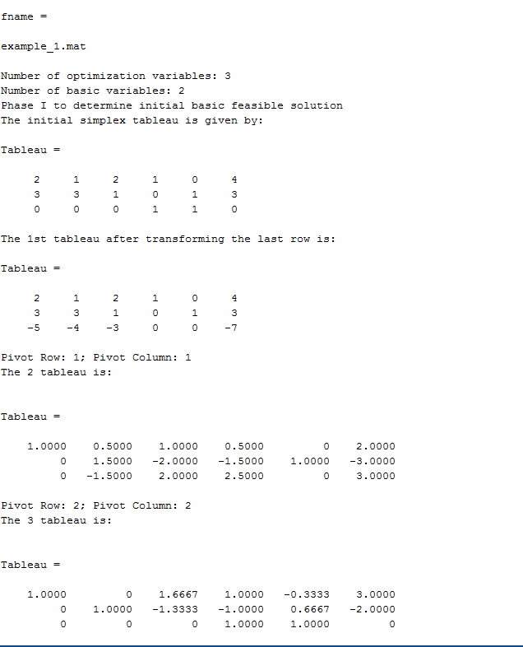
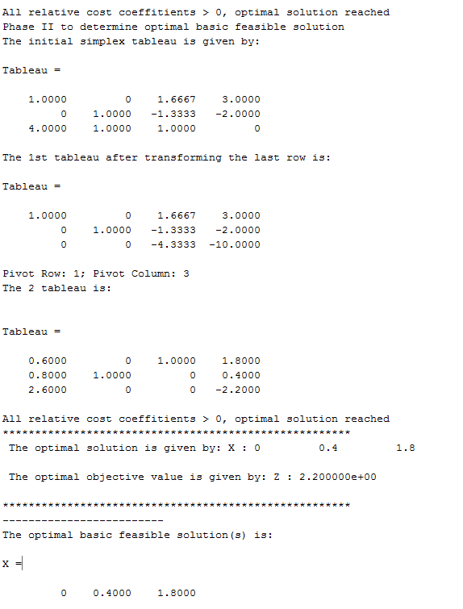
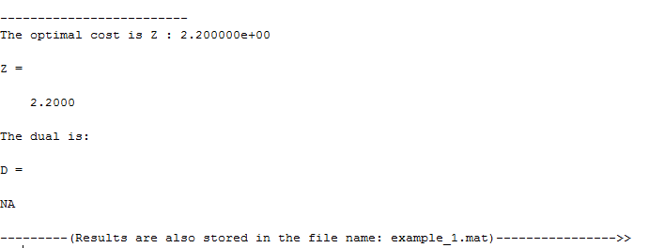

Example 2:
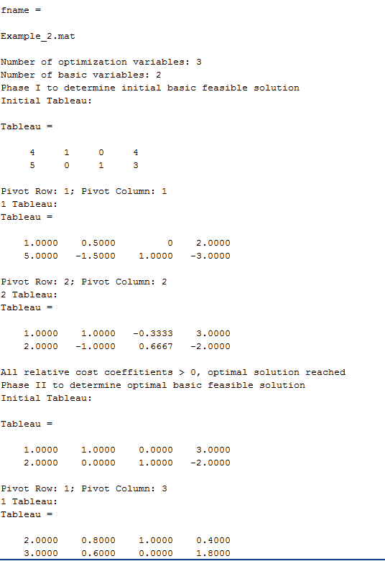
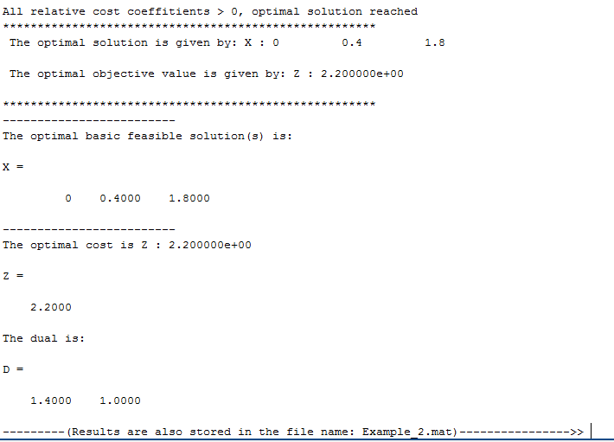

Example 3:
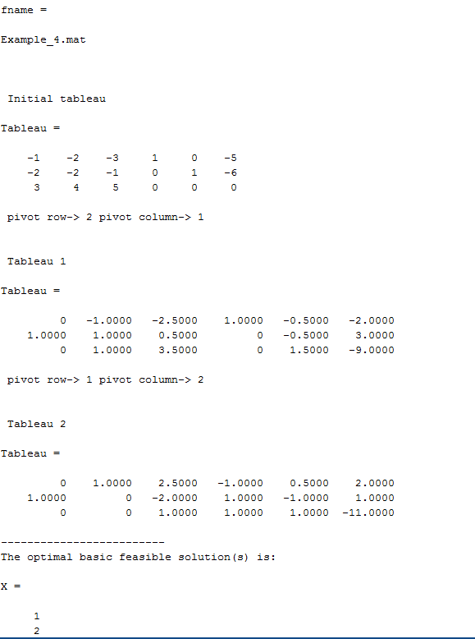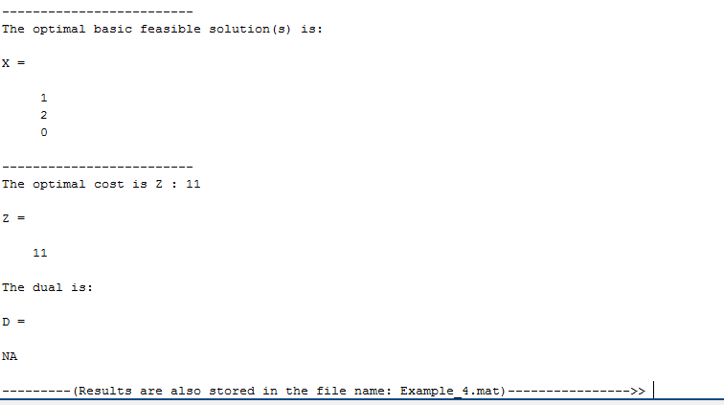

Example 4:
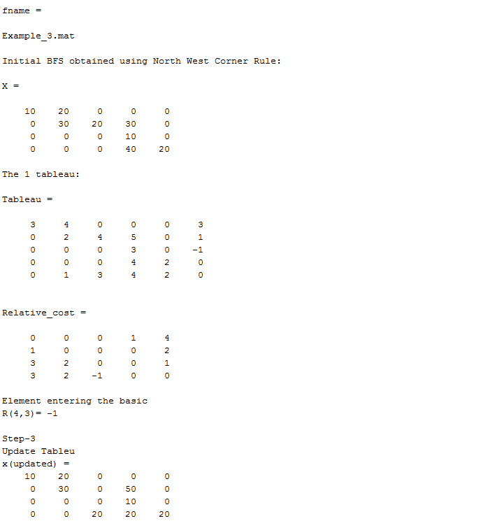
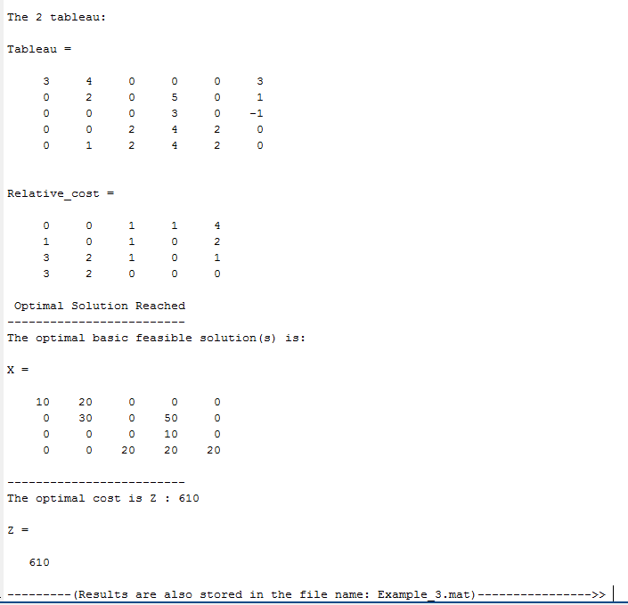

Example 5
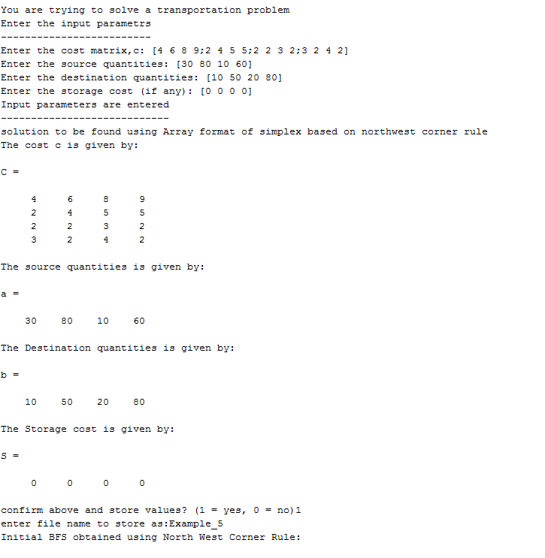
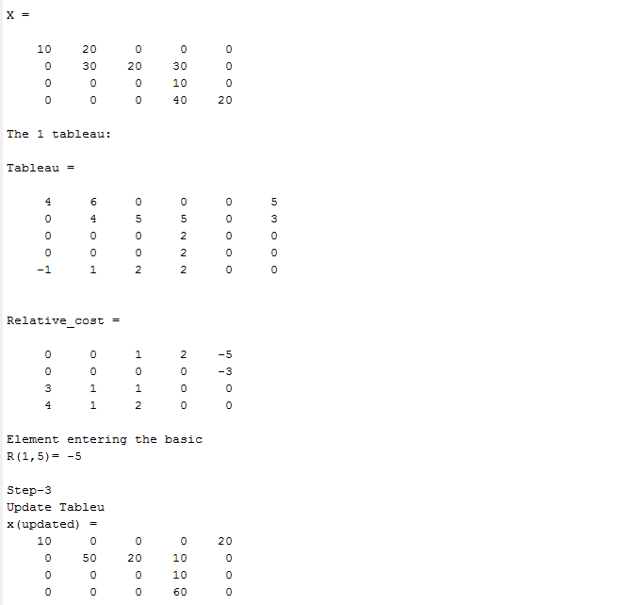
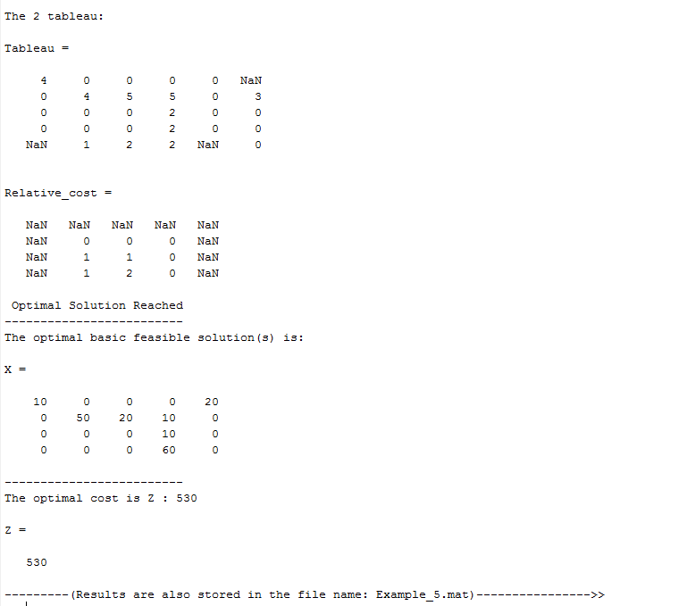

Flowcharts for the different function blocks:

Two Phase Simplex:
Stop
Print optimal X, Z
Print Infeasible
No
Yes
Feasible?
Stop
Print Infeasible
Yes
No
Feasible?
Perform Simplex Iterations until Convergence
Perform Simplex Iterations until Convergence
Phase – II:
Remove dummy variables. Form the phase – II initial tableau:
$\left[\begin{matrix}A & & B^{-1}b \\ c & & 0\end{matrix}\right]$
Start
Phase – I:
Create dummy variables equal to the number of rows of A. Initialize the first phase -I tableau of the form:
$\left[\begin{matrix}A & I & b \\ 0 & 1…1 & 0\end{matrix}\right]$ where $I$ is of dimension size(A,2)
Input c, A, b

Revised Simplex:
Stop
Print optimal X, Z
Print Infeasible
No
Yes
Feasible?
Stop
Print Infeasible
Yes
No
Feasible?
Perform Revised Simplex Iterations until Convergence
Perform Revised Simplex Iterations until Convergence
Phase – II:
Remove dummy variables. Form the phase – II initial tableau:
$\left[\begin{matrix}A & & B^{-1}b \\ c & & 0\end{matrix}\right]$
Start
Phase – I:
Create dummy variables equal to the number of rows of A. Initialize the first phase -I tableau of the form:
$\left[\begin{matrix}A & I & b \\ 0 & 1…1 & 0\end{matrix}\right]$ where $I$ is of dimension size(A,2)
Input c, A, b

Dual Simplex:
No
No
Yes
Stop
Output X,Z
Yes
converged?
Perform Dual update (dual feasible) to obtain A, x , Z
If RD < 0
Tableau is:
$\left[\begin{matrix}A & I & b \\ c & 0 & 0\end{matrix}\right]$
Where $I$ is identity of dimension m.
m = number of rows of A
n = number of columns of A
Input A,b,c
Start

